Project Logs and Screenshots:

Setting up of my env:

06/17: 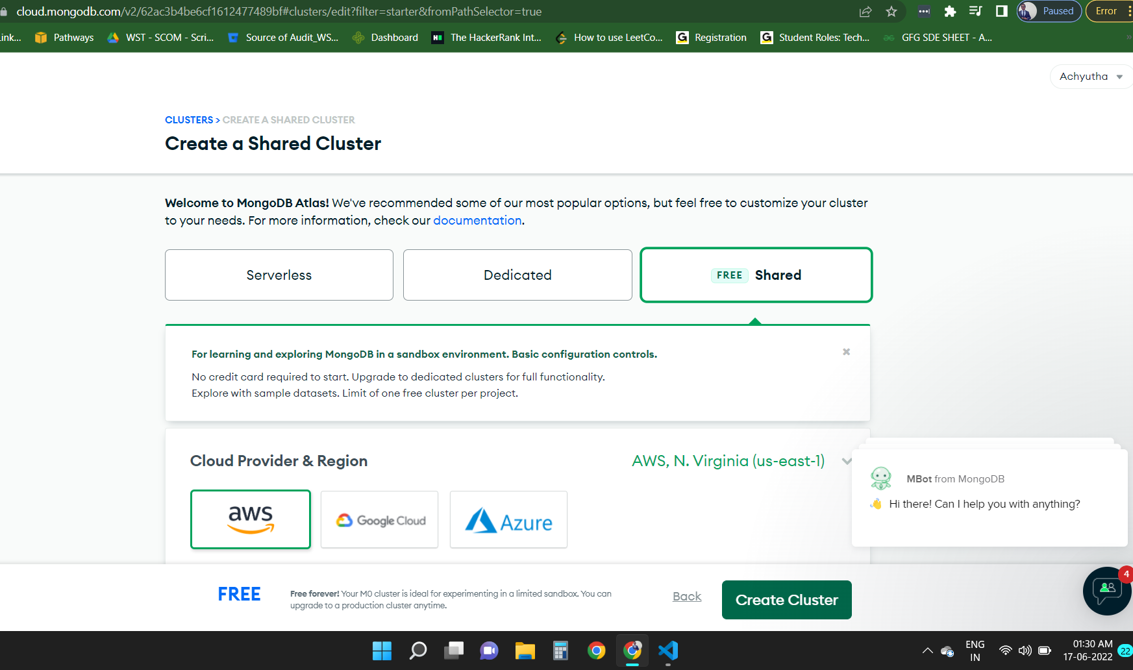

Making a mock json and UI for rendering the required data.

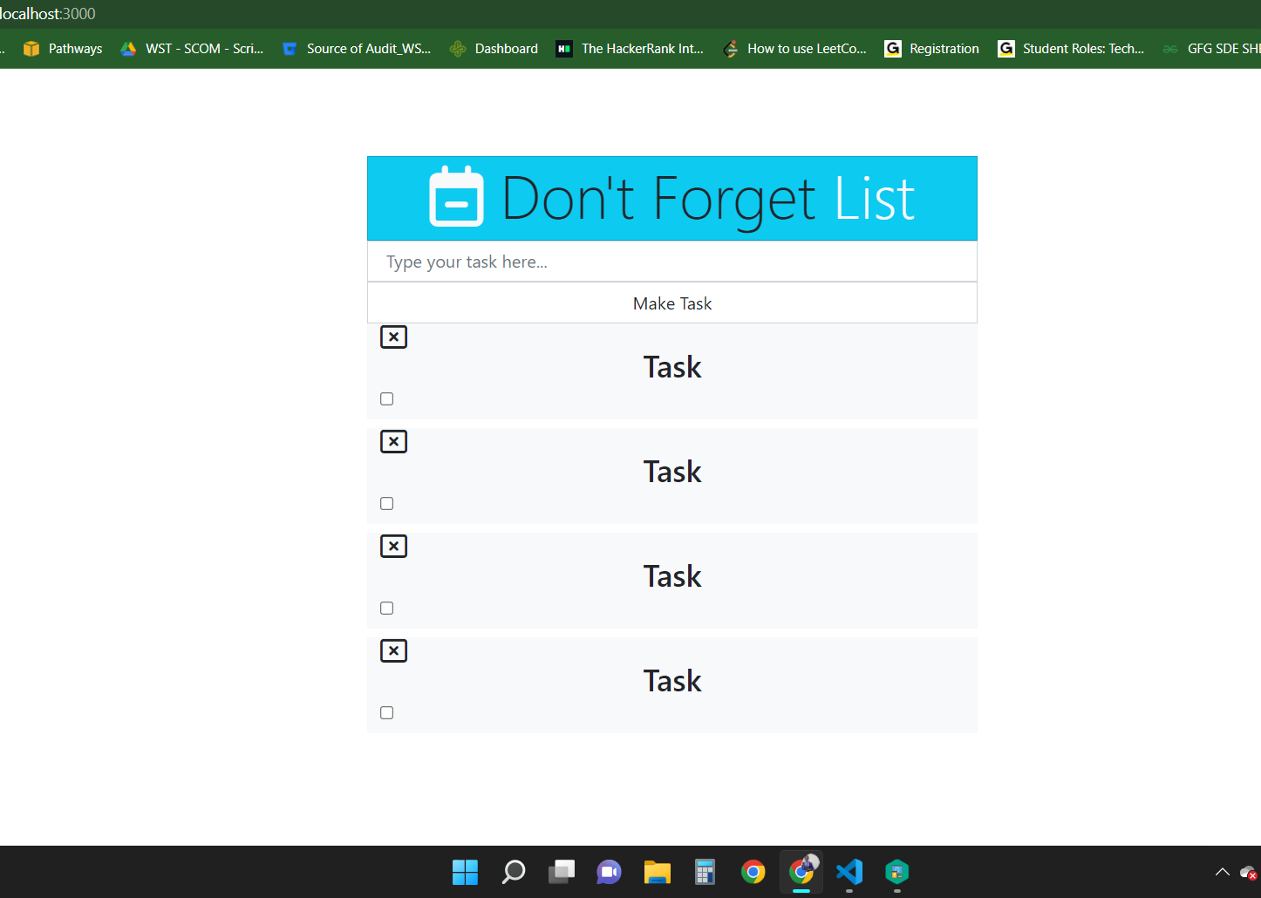

Custom making and hard coding the todo tasks in the UI

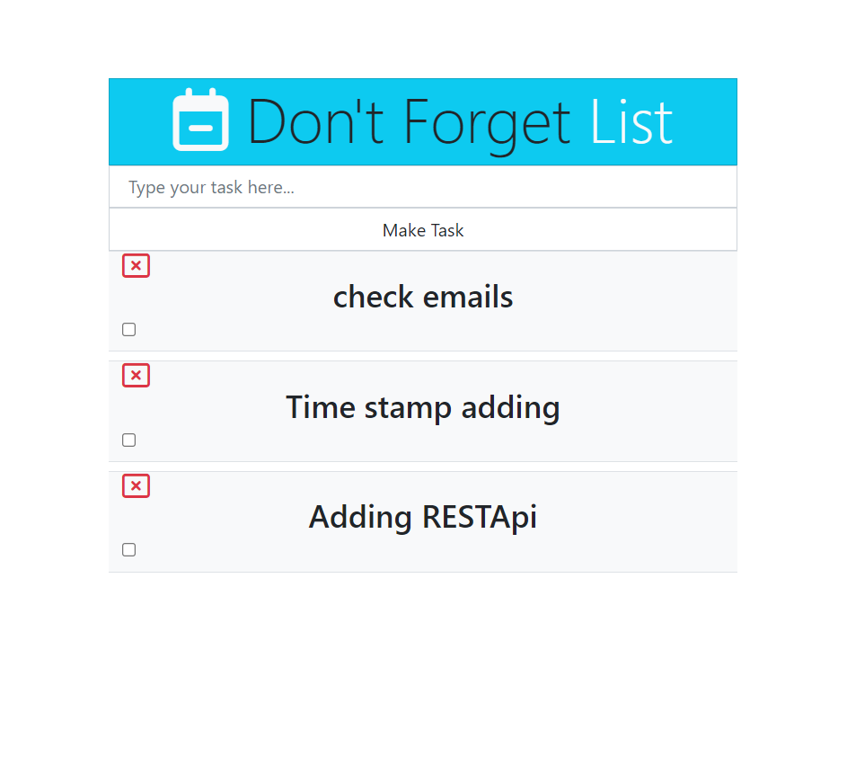

Schema for the Database: (BASIC)

state={

id:4,

title:"",

complete:false

}

Online database setup and hitting the API endpoints :

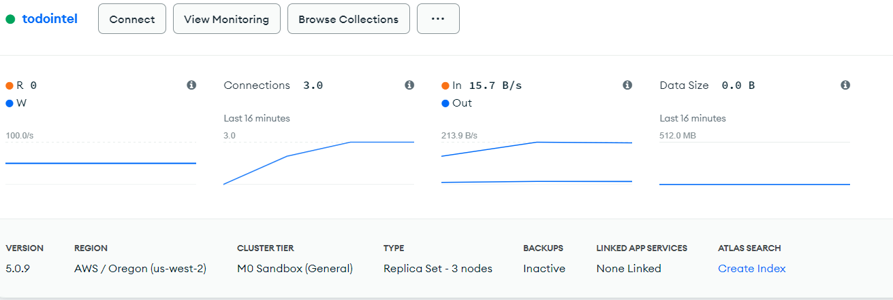

Initial two task already created and the next image takes new task creation:

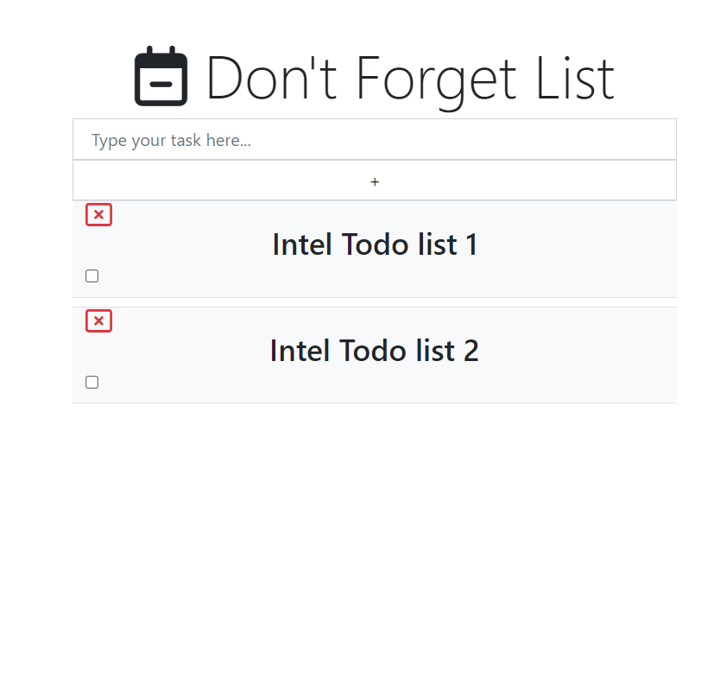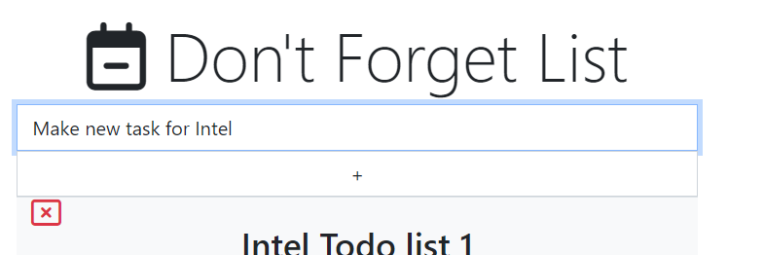

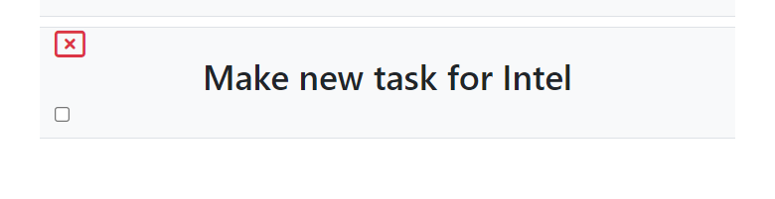

Clicking on the checkbox after the task is completed and modify it if required.

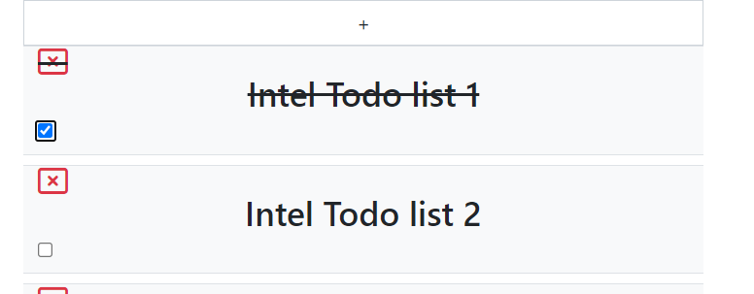

Finally with the help of the close button, you can delete the todo task on the list.

